Numbers : Base system

https://www.facebook.com/events/841841712655390/

1.Let's start [#Base_System](https://www.facebook.com/hashtag/base_system?source=feed_text)

In base 10 we use digits from 0 to 9, so in base n we use digits from 0 to n-1.

So if the base was 6 instead of 10, then while doing counting we will go like  
0,1,2,3,4,5,10,11,12,13,14,15,20,21,22,23,24,25,30... and after 55 it will be 100 as next number.

Observe ^

I think many are aware of all this.. are you ?

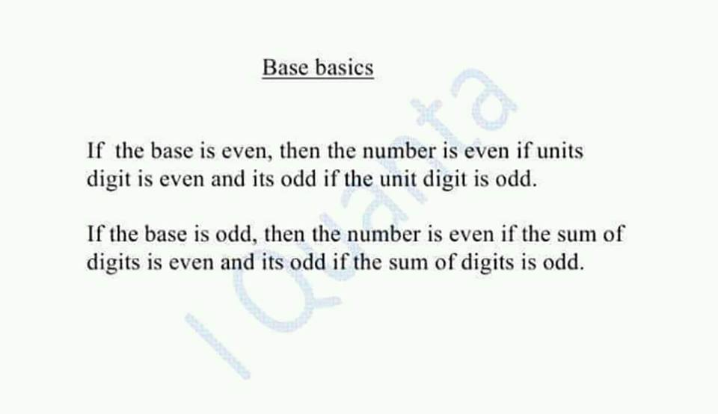

Try to relate with base 10.   
  
Base 10 (even) me kya karte hn to decide if the number is even or odd , we see its unit digit , Right ?   
  
Same applies for all other even bases.

if base is even, unit digit se decide kar lo.. if base is odd sum of digits se decide karlo

Even or odd ?

341 In base 19 ?

Base odd : Sum of digits.  
  
As 3+4+1 = 8 (even)  
  
Hence number is even.

Largest 4-digit number in base 5 is ?

4444

Largest 7 digit number in base 3 is ? Write its decimal representation too!!

2222222, 3^7 - 1

[#Concept](https://www.facebook.com/hashtag/concept?source=feed_text)

Maximum decimal value of an n-digit number in base b= (b)^n -1

For example: max 3 digit in base 2= (111) = 2^3-1 = 7( in decimal)

And max 5 digit in base 4: (33333) = 4^5-1 = 1023( in decimal )

Relate with base 10  
  
max value in base 10   
  
single digit : 10 - 1= 9  
double digit : 10^2 - 1 = 99  
triple digit : 10^3 - 1 = 999  
  
so on...

For base 7   
  
Single digit : 7 -1 = 6   
Double digit : 7^2 -1   
Triple digit : 7^3 - 1

Among the options which cannot be prime in any base ?

342  
241  
324  
172   
not

172 because it'll be even in any base

Oa: 172   
  
Solution: As we know an even cant be a prime except 2.   
  
so 172 in base even is even (as units digit is even)  
  
and its even in base odd (as sum of digits is even)  
  
so it is even in any case, so it cant be prime. while others can be odd in some bases.

Oa: 172   
  
Solution: As we know an even cant be a prime except 2.   
  
so 172 in base even is even (as units digit is even)  
  
and its even in base odd (as sum of digits is even)  
  
so it is even in any case, so it cant be prime. while others can be odd in some bases.

[#Conversion](https://www.facebook.com/hashtag/conversion?source=feed_text) there are 2 types of conversion in bases. Type 1 here:

1. To convert number N from base 10 to any other base "b".

●keep on dividing the number N by b and note the remainder.   
●final answer will be remainders in reverse direction.

eg. (25)10 when converted to base 4 it will be   
25 mod 4 =1  
[25/4]=6 mod 4 = 2  
[6/4]=1 mod 4 =1

so 121

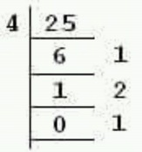

Q. Convert 345 in base 5

345 mod 5 = 0

345/5 = 69 mod 5 = 4

69/5 = 13 mod 5 = 3

13/5 = 2 mod 5 = 2

(2340)5

345 mod 5 = 0   
[345/5] = 69 mod 5 = 4  
[69/5]=13 mod 5 = 3  
[13/5]=2 mod 5 = 2  
  
now rem in reverse order = 2340  
  
so 345 in base 10 when converted to base 5 it becomes 2340.  
  
Clear ??

[#Base](https://www.facebook.com/hashtag/base?source=feed_text) Conversion : Type 2

To convert number from other bases to base 10,

Break the digits and multiply with respective powers of the base.

Ex- convert (456) ( which is in base 7) to base 10

start from last

6*7^0 + 5* 7^1 + 4*7^2

=6 + 35 + 196 = 237

hence 456 in base 7 is 237 in base 10

Convert 2146 from base 8 to base 10

2146 in base 10 is written as 2*10^3 + 1*10^2 + 4*10 + 6*10^0 = 2146  
  
2146 in base 8 to 10 : 2*8^3 + 1*8^2 + 4*8 + 6 = 1126  
  
Clear ?

[#Concept](https://www.facebook.com/hashtag/concept?source=feed_text)

If you have a set of 5 digit numbers in base 3, it will be from {10000 to 22222} = 3^4 to (3^5-1) in decimal

If you have a set of 7 digit numbers in base 5, it will be from {1000000 to 4444444} = 5^6 to (5^7-1) in decimal

So smallest number in base b is b^(n-1)  
  
And largest b^n - 1

In base 10   
  
Single digit , n =1  
Smallest 10^(1-1)= 1   
Largest 10^1 -1 = 9   
  
Double digit, n =2   
Smallest 10^(2-1)= 10  
Largest 10^2 -1 = 99  
  
Triple digit, n = 3   
Smallest 10^(3-1)= 100  
Largest 10^3 -1 = 999  
  
Clear ?

 In other bases b just replace, 10 with b

So guys just try to correlate with base 10 and it will look quite easier.

As in smallest 4 digit number is 10^3 and largest is 10^4-1

So in base b it will be b^3 and largest b^4-1.

Is it clear?

Q) How many numbers have 6 digits in both base 4 and as well as base 5?

 Numbers having 6 digits in base 4   
  
from 4^5 to (4^6-1) = 1024 to 4095 in decimal.  
  
●Numbers having 6 digits in base 5 :   
  
from 5^5 to (5^6-1) = 3125 to 15624 in decimal.  
  
So, numbers meeting both criteria are {3125 to 4095} including both.   
  
So (4095-3125)+1 = 971 numbers.

How many 4 digit positive integral numbers are there in base 7 ?

6*7*7*7 = 2058  
first digit can take 6 values from 1 to 6, rest of the digits can take 7 values from 0 to 6

Oa : 6*7^3  
  
Soln: in base 7 we only have digits from 0 to 6  
  
So 6*7*7*7=6*7^3 = 2058●  
  
OR   
  
7^4 - 7^3 = 2058  
  
Cool ?

Max 7^4-1   
Min : 7^(4-1)= 7^3   
  
Total : Max - Min +1  
  
=> (7^4-1) - (7^3) +1 = 7^4-7^3= 2058

2058 in base 7 is ??

(6000)7

How many 4 digit positive integral numbers are there in base 7 if you are counting the numbers in the same base system.

Calculation base 10 : 6*7^3  
  
Soln: in base 7 we only have digits from 0 to 6  
  
So 6*7*7*7=6*7^3 = 2058   
  
To get it in base 7 convert it into base 7 as last ques => 6000

Or simply you see in base 10  
  
There are 90 : 2 digits,   
900 : 3 digits   
9000 4 digits   
  
So in base 7   
  
60, 600, 6000 .  
  
So 4 digits => 6000

Q. In a number system 12, 20,24 are in an arithmetic progression. What is the base of the number system?

Let base be x   
  
12 = x + 2  
  
20 = 2x+0  
  
24 = 2x + 4  
  
In AP , common difference is constant   
  
So Equate the common difference   
  
2x - (x+2) = (2x+4) - 2x   
  
=> x-2 = 4   
  
=> x = 6

[#Concept](https://www.facebook.com/hashtag/concept?source=feed_text)

Correlate with base 10.

As in to find last digit we find remainder with 10  
And to find last two digits we find mod 10^2  
.  
So on....

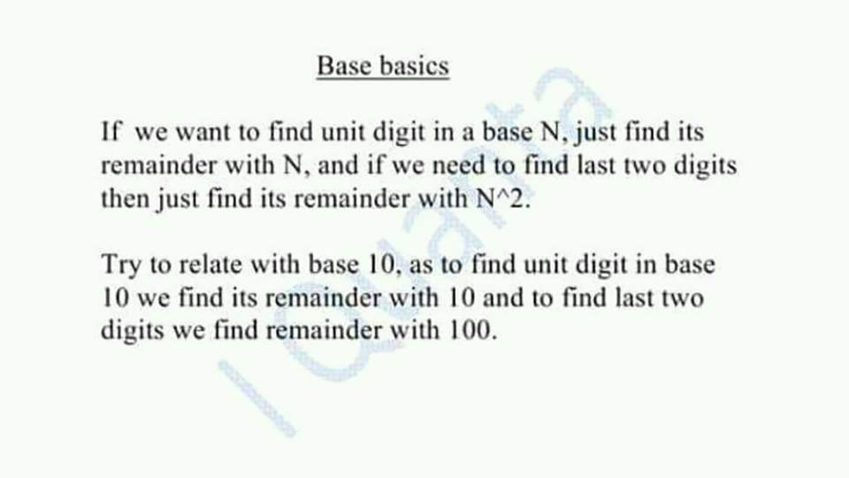

Q. Find the unit digit of 17 in base 3 .

17 mod 3 = 2

oa : 2

Q) Find the last two digits of 47^23 in base 4

47^23 mod 16 = (-1)^odd = - 1 = 15   
  
But 15 can't be used in base 4 so convert 15 in base 4 we get 33  
  
Oa : 33●  
  
Also u can confirn by just checking unit digit by finding 47^23 mod 4 = 3 .. so unit 3 to 15 last 2 kese.

Last concept for Numbers as well as Base!!

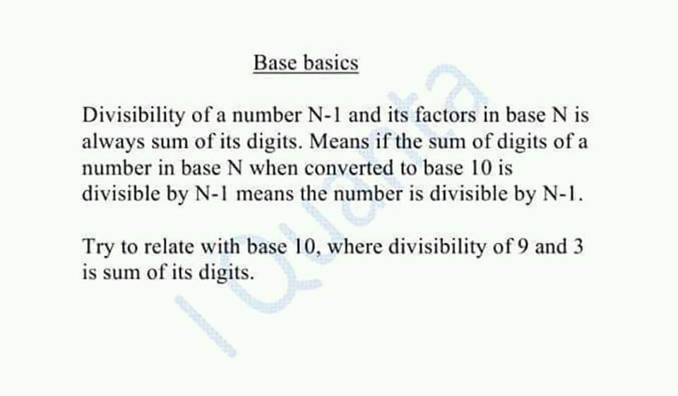

What is the remainder when 5^3 written in base 8 is divided by 7 ?

 If 125 is already in base 8, then just do 1+2+5 mod 7 = 1   
  
here it says number when written in base 8.   
  
So First convert 125 to base 8  
=> 175   
  
And now apply divisibility rule  
  
in base 8 the divisibility of 7 is sum of digits   
  
So 1+7+5=13 mod 7 = 6.

Q. 25883 which is in base 17 , when divided by 8, Remainder will be ?

In base 17, the divisibility of 16 will be sum of digits and also divisibility of all its factors . ( just like for 9 in base 10 )   
  
So same is the divisibility of 8,4,2,1 ie all the factors of 16.   
  
Hence just 2+5+8+8+3 mod 8   
  
= 26 mod 8 = 2

Past CAT

In a number system the product of 44 and 11 is 1034.The number 3111 of this system ,when converted to decimal system is?

let base be x

so (4 + 4x) (1 + x) = (4 + 3x + x^3)

x^3 - 4x^2 - 5x = 0

x = 5.

(3111)5 = (1 + 5 + 25 + 375)10 = (406)10

Basics : any number abc in base n can be written as an^2 + bn + c  
  
Or ab in base n : an + b . So,  
  
Product of 44 and 11 in base n is (4n + 4 )(n + 1)= 4+8n+4n^2  
  
1034 in base n => n^3 + 0*n^2 + 3n + 4   
  
=> n^3 + 3n + 4 = 4 + 8n + 4n^2  
n^3 - 4n^2 - 5n = 0  
n^2 - 4n - 5 = 0  
n = 5  
  
3111 becomes = 1 + 5 + 5^2 + 3*5^3 = 375 + 25 + 6 = 406